Name___________________ Date__________________ Period_______
Unit 2 Solar System TEST Review
DUE DATE______________ TEST DATE______________
Make flash cards with the following questions. You must have the full question/drawing on one side and the answers/drawings on the back side of the card to receive any points on the test. This will go as a grade and must be turned in on the due date or you will not be able to use them on the test.
- What does it mean when a planet has a large solid core?
- Which planet more likely has a mass more than 300 time greater than the mass of the Earth?
- Why do we use telescopes?
- Draw an elliptical galaxy. Explain what an elliptical galaxy is.
- Draw a spiral galaxy. Explain what a spiral galaxy is.
- How are planets classified as either inner or outer planets?
- Where are asteroids located?
- When 2 stars have the same color, what does that mean?
- How big or small are the stars that we can see at night?
- How close are the stars in the night sky that we can see from Earth?
- What is an irregular galaxy? Draw one.
- Which planet has a feature known as the Great Dark Spot?
- Which set of planets (outer or inner planets) have many moons?
- What makes the sun more important than the other stars?
- What is a difference between a barred spiral galaxy and a normal spiral galaxy?
- If you saw a meteor tonight, what would it look like?
- What do Earth and Saturn have in common?
- What can you find that would most likely be found between Mars and Jupiter?
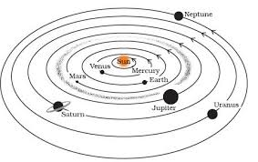
- What is “Sirium”?
- What is the difference between a meteoroid and a meteorite?
- What is another name for Saturn, Uranus and Neptune?
- What do Saturn, Uranus and Neptune have in common with Jupiter?
Unit 2 Solar System TEST Review ANSWERS
- What does it mean when a planet has a large solid core?
Mercury’s planet has more solid iron in its core (middle of the planet) than any other planet.
- Which planet more likely has a mass more than 300 time greater than the mass of the Earth? Jupiter
- Why do we use telescopes? T be able to see more detail about a small area of the sky.
- Draw an elliptical galaxy. Explain what an elliptical galaxy is. An elliptical galaxy is brightest toward the center of the galaxy.
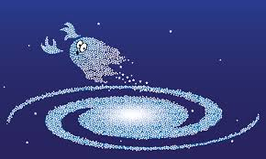
- Draw a spiral galaxy. Explain what a spiral galaxy is. The center is crowded with stars & the number of stars decreases farther out.
- How are planets classified as either inner or outer planets? Based on their distance from the sun
- Where are asteroids located? Between the inner and outer planets
- When 2 stars have the same color, what does that mean? That they must have the same temperature
- How big or small are the stars that we can see at night? Many times larger than Earth
- How close are the stars in the night sky that we can see from Earth? The stars visible at night are located very far from Earth

- What is an irregular galaxy? Draw one. Irregular galaxies look “jumbled”. They don’t have a certain shape.
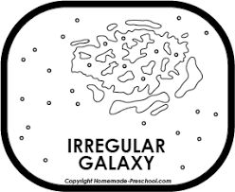
- Which planet has a feature known as the Great Dark Spot? Neptune
- Which set of planets (outer or inner planets) have many moons? The outer planets
- What makes the sun more important than the other stars? When compared to other stars, the sun is very close to the Earth.
- What is a difference between a barred spiral galaxy and a normal spiral galaxy? A barred spiral galaxy has a bar shaped group of stars in the center of it. A normal spiral galaxy has “arm-like” appendages that come out from center of the galaxy.
- If you saw a meteor tonight, what would it look like? A streak of light produced by a small chunk of rock passing through Earth’s atmosphere.
- What do Earth and Saturn have in common? Earth & Saturn both rotate about an axis.
- What can you find that would most likely be found between Mars and Jupiter? Asteroids (Asteroid belt)
- What is “Sirium”? It is a star and it is located outside of the solar system.
- What is the difference between a meteoroid and a meteorite? A meteoroid is a hunk of rock traveling through the solar system. A meteorite is a meteoroid that reaches the surface of the Earth.
- What is another name for Saturn, Uranus and Neptune? Jovian Planets
- What do Saturn, Uranus and Neptune have in common with Jupiter? They are similar to Jupiter because they have a thick gaseous atmosphere.

