Adkins Study Guide from Study Island Unit 1 Test Nature of Science

Scientific Investigations
Question 1 .
A scientist is observing elephants in Asia. He notices that a specific species of moth lands on the faces of the elephants. On closer observation, he sees that the moths irritate the eyes of the elephants and then drink the tears that emerge.
What scientific question could the scientist ask to explain this?
A. What nutrients that moths need are in elephant tears?
B. Do other species of moths also drink elephant tears?
C. How can the moths be kept off the elephants' faces?
D. all of these
Question 2 .
There are many different types of scientific investigations. Which of the following forms requires the identification and control of variables?
A. laboratory experiments
B. model-building
C. observational field studies
D. collection of specimens
Question 3 .
Laboratory experiments, observational field studies, and model-building are all examples of different forms of scientific investigations. In what way do laboratory experiments primarily differ from other forms of scientific investigations?
A. Laboratory experiments involve the identification and control of variables.
B. A laboratory experiment is the only accepted form of investigation within the scientific community.
C. Studies about how things behave in nature or studies involving very large objects are best answered through laboratory experiments.
D. Data can only be generated through laboratory experiments, not other forms of investigation.
Question 4 .
Kara built a model of how molecules behave when they are in solid form. She filled a clear plastic box with marbles to the very top and put the lid on the box. When she shakes the box, the marbles can barely move.
Which of the following is a limitation of Kara's model?
A. The marbles have limited motion, but molecules in solids move a lot.
B. The marbles must be held in a box, but solids hold together without a container.
C. The marbles are all the same shape, but molecules all have unique shapes.
D. The marbles are made out of atoms, but molecules are not.

Question 5 .

Scientific inquiry includes many different types of activities and processes. When someone makes measurements using scientific tools, what part of the inquiry process are they performing?
A. communicating evaluations
B. formulating questions
C. collecting data
D. evaluating data
Question 6 .
A hypothesis is a statement that can be tested through a scientific investigation. What is the purpose of writing a hypothesis?
A. Hypotheses always match the conclusion.
B. Hypotheses help identify the variables.
C. Hypotheses give details about the data.
D. Hypotheses suggest new questions for further investigations.
Question 7 .
Scientific knowledge is most useful when trying to understand
A. philosophy.
B. the natural world.
C. religion.
D. art.
Question 8 .
Experiments are often performed in science to produce data or evidence. This evidence is then analyzed to draw conclusions. The use of evidence to formulate conclusions encourages _______.
A. bias
B. objectivity
C. subjectivity
D. partiality
Question 9 .
Derek lives in a hot, humid climate. He has two rose bushes in pots in his yard. The rose bushes grow quickly and bloom with large, red roses. Derek moves to a cold, dry climate at the same altitude and notices that his rose bushes stop growing and do not have large blooms. He hypothesizes that the rose bushes are not receiving enough water because he is now in a dry climate. He waters them more often, but they do not improve.
Which of the following scientific questions should he ask next to find out what is wrong with his roses?
A. Which rose bush has larger, more colorful blooms?
B. Does temperature affect the growth of the rose bushes?
C. Do rose bushes grow better in high or low altitudes?
D. How much do rose bushes cost in his new area?

Question 10 .
Heath broke a jawbreaker candy in half using a hammer. He noticed that the layers in the jawbreaker could be like a model for the crust, mantle, outer core, and inner core of the Earth.
What is one limitation of using the jawbreaker shown above as a model for Earth's layers?
A. The outside layer is the thinnest layer.
B. The layers are all made out of the same material.
C. The jawbreaker can be split to show the inside.
D. The jawbreaker has four different layers.
Question 11 .
Trisha is learning how to do a first-aid procedure known as CPR. She is practicing using a mannequin, or a model of the top half of the human body.
What is one limitation of a CPR mannequin?
A. It is not possible to check for a real pulse on a CPR mannequin.
B. It is not possible to press down on the chest of a CPR mannequin.
C. It is not possible to lay a CPR mannequin on the floor.
D. It is not possible to breathe into the mouth a CPR mannequin.
Question 12 .
Scientific theories are explanations for naturally occurring events or phenomena. Although scientific theories require extensive observations and experimentation, they can change over time as new evidence is discovered.
Scientific laws are principles that are also based on extensive observations and experimentation. Although scientific theories can develop into laws, a theory can only be declared a law if it is proven to be without exception under certain stated conditions.
Which of the following is true regarding scientific theories, laws, and knowledge?
A. Scientific theories can lead to scientific knowledge, but scientific theories are not related to scientific knowledge.
B. Scientific theories and laws develop from the acquisition of scientific knowledge.
C. Scientific knowledge must be proven by both scientific theories and laws.
D. New scientific knowledge is gained by memorizing scientific theories and laws.
Question 13 .
Scientist Jordan makes a discovery and publishes the results for other scientists to read. Scientist Leesha tries to repeat the experiment and cannot make it work. Her results are also published. Scientist Jordan looks at his data again and finds that the discovery only works under certain conditions. He publishes the change. Now scientist Leesha repeats the new method and finds the same results as Jordan, but another scientist, Winslow, gets different results. What does this story demonstrate?
A. that scientific knowledge is developed by individual scientists in isolation
B. that scientists are really good at arguing
C. that scientific knowledge results from a lot of debate and confirmation
D. that scientific knowledge is impossible to obtain

Question 14 .
Scientific knowledge is based on
A. observations and inferences.
B. political and social views.
C. bias and opinions.
D. hypotheses and doubt.
Question 15 .
Charles knows that adding salt to water causes the freezing point of water to be lowered, but he wants to know if rock salt affects the freezing point more than table salt.
Charles performed an investigation in his classroom in which he measured the freezing point of 250 mL of water. He used this measurement as his control. Then, he dissolved equal amounts of rock salt and table salt in two identical 250 mL beakers of water. Finally, he measured the freezing points of each beaker of water, analyzed his results, and formed a conclusion.
What type of investigation did Charles perform?
A. model-building
B. observational field study
C. collection of specimens
D. laboratory experiment
Question 16 .
Scientific inquiry includes many different activities. Which of the following is a process that is typically performed during a scientific inquiry?
A. communicating data
B. collecting data
C. constructing investigations
D. all of these
Question 17 .
Scientific inquiries usually begin with the formulation of a question. Can a scientific inquiry be constructed about any question?
A. Yes; one universal scientific method can be applied to any question.
B. No; the question must be testable or scientifically investigable.
C. No; only questions about supernatural events may be investigated.
D. Yes; it is possible to investigate any question through scientific inquiry.

Question 18 .
Andrea is performing an experiment in which she needs to know when a strong acid is present. She is not sure which indicator to use, so she looks up the following table in her science textbook.
Indicator | pH range
thymol Blue | 1.2 - 2.8
phenol Red | 6.4 - 8.0
phenolphthalein | 8.0 - 10.0
trinitrobenzoic acid | 12.0 - 13.4
According to the textbook, which indicator should Andrea use?
Hint: Neutral substances have a pH of 7. Acids have a pH that is less than 7, and bases have a pH that is greater than 7.
A. phenol Red
B. phenolphthalein
C. trinitrobenzoic acid
D. thymol Blue
Question 19 .
Students used to be taught that all the planets, stars, and the Sun moved around the Earth. Scientists used observations they had made to chart out the paths each planet must follow. The paths were very complicated. For example, the path Mars took around the Earth is shown below:

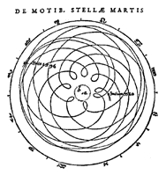

Using this model, scientists could predict fairly well where the planets would be and how they would move at any point in the near future.
Today, students are taught that all the planets move around the Sun and that the Earth spins on its axis once every 24 hours. Which of the following played the largest part in changing what students are taught?
A. The world leaders changed their minds about what students should be taught.
B. The planets used to move around the Earth, but now they move around the Sun.
C. A scientist came up with a theory that the planets move around the Sun.
D. Enough data was gathered to show how the planets move.
Question 20 .
George is interested in insects and wants to do an experiment. Which of the following is a scientific question about insects that he could investigate with an experiment?
A. Are ladybugs prettier than beetles?
B. Do different food types affect the growth rate of beetles?
C. Do ants feel anxiety?
D. Why are there so many different kinds of insects in the world?
Question 21 .
For most of the first 1,800 years in the common era, most people, including scholars, did not believe in sexual or asexual reproduction for many organisms. They thought many creatures, including frogs and mice, came from nonliving things. This was the theory of spontaneous generation. For example, maggots were believed to simply appear in meat as it spoiled. Today we know that maggots come from eggs that were laid on or in the meat by their mothers.
Louis Pasteur proved that living organisms do not just appear. Broth that is left sitting out for a while will grow cloudy as small organisms live and grow in it. Louis Pasteur boiled broth and let it cool without coming into contact with any "particles" in the air. Broth treated that way did not grow cloudy.
Louis Pasteur's experiment showed that small organisms that live in broth do not come from the broth itself. Which of the following best describes this statement and how it changed what scientists know?
A. It is a result that was predicted by the theory of sexual reproduction, proving that theory to be correct.
B. It is a scientific theory of how life begins that fits the facts better than spontaneous generation.
C. It is a set of detailed observations of how single-celled organisms live and reproduce.
D. It is a scientific observation that goes against the theory of spontaneous generation, so the theory must be wrong.
Question 22 .
Which of the following are included in scientific processes, methods, and knowledge as a result of science being a human endeavor?
A. creativity
B. subjectivity
C. discovery
D. all of these
Question 23 .
Addison has two dogs that are sisters. One of the dogs has white fur and the other dog has black fur.
What scientific question could Addison ask based on this observation?
A. How is fur color determined in dogs?
B. Which color of fur is the prettiest?
C. How fast do the dogs run?
D. Which of the dogs is the most friendly?
Question 24 .
Eric wants to perform an investigation on red blood cells, but before beginning his investigation, he wants to learn more about them. Which of the following is an appropriate reference material that Eric could use to learn more about red blood cells?
A. a scientific journal
B. a science-fiction book about blood
C. a friend from school
D. a newspaper editorial
Question 25 .
How is science different from other subjects that involve thought, such as art, philosophy, and religion?
A. Science requires more faith rather than logic and reason.
B. Science is more objective, since it is predominantly based on evidence.
C. Science is more subjective, since theories are based on opinions.
D. Science has a tendency to be heavily influenced by society.
Question 26 .
Dr. Grey performed an experiment to test how temperature affects activity levels in mice. She put one group of mice in a cold environment and another group of mice in a hot environment.
Everything else about the two environments was the same, including the type and amount of food and water. She allowed the experiment to last for a few generations of mice and tested the activity levels of the different groups.
There was no change in the activity levels of the mice, but she noticed that the mice in the cold environment had much darker, thicker fur than the mice in the hot environment. What scientific question could she ask based on her results?
A. Do the mice in the cold environment run faster than the mice in the hot environment?
B. Which group of mice is the most attractive?
C. Does food type have an effect on fur color and thickness in mice?
D. Does temperature have an effect on fur color and thickness in mice?
Question 27 .
Scientific laws describe natural relationships that have been tested repeatedly and are generally accepted as universal and true. Which of the following describes a scientific theory?
A. a proven fact about a natural phenomena
B. the outcome of a single experiment
C. a proposed explanation for natural phenomena, supported by evidence
D. a prediction about what will happen during a scientific investigation

Question 28 .
Scientific laws describe natural relationships that have been tested repeatedly and are generally accepted as universal and true. Which of the following describes a scientific theory?
A. a proven fact about a natural phenomena
B. the outcome of a single experiment
C. a prediction about what will happen during a scientific investigation
D. a proposed explanation for natural phenomena, supported by evidence
Question 29 .
A scientist wants to know how individual lions within a pride interact with each other in their own environment.To do this, the scientist sedates and tags all of the lions within a pride. Then, he places several remotely-controlled video cameras near the lions' den and performs an observational field study. He collects continuous video footage over the span of one year, analyzes the video, and then forms conclusions based on his observations.
This example shows that
A. observational field studies are not a valid form of scientific investigation.
B. conditions and variables are best controlled in observational field studies.
C. not all scientific knowledge is gained through controlled laboratory experiments.
D. there is only one way to acquire scientific knowledge.
Question 30 .
Which of the following is a limitation of models?
A. Models are often safer to study than the objects or events that they represent.
B. Models usually do not have exactly the same features as the objects or events that they represent.
C. Sometimes models provide data when data cannot be acquired from natural objects or events.
D. It is often easier to study models rather than the objects or events that they represent.
Question 31 .
Scientific experiments often produce new scientific knowledge.
What usually happens if a scientific experiment generates new knowledge that doesn't agree with an existing theory?
A. The new knowledge is ignored in favor of the old theory.
B. Scientists choose whichever side seems to have the most followers.
C. The new knowledge is used to reevaluate the theory.
D. Science is abandoned as a way to generate knowledge.
Question 32 .
Scientific questions can be asked based on which of the following?
A. scientific investigation
B. previous research
C. observations
D. all of these

Question 33 .
George uses crayons to draw a model of the solar system on a sheet of paper. What is a limitation of this model?
A. George cannot place the planets in the correct order from the Sun.
B. The model cannot show that the planets differ in size.
C. The model cannot show that the planets differ in color.
D. George cannot move the planets around the Sun.
Question 34 .
Scientific laws describe natural relationships that have been tested repeatedly and are generally accepted as universal and true. Which of the following describes a scientific theory?
A. a prediction about what will happen during a scientific investigation
B. a proposed explanation for natural phenomena, supported by evidence
C. a proven fact about a natural phenomena
D. the outcome of a single experiment
Question 35 .
Since the beginning of time, some people have believed that the Earth is flat. Beginning around 300 B.C., however, some began to wonder if the Earth is actually spherical in shape.
Those that favored the flat Earth theory made the following observations:
- The Earth is stable because it is a flat landmass sandwiched between a flat layer of air and a flat layer of water.
- If the Earth is spherical, then oceans should be curved on top, but they aren't.
- Some rivers flow for hundreds of miles but only fall a few feet. The rivers should fall farther if the Earth is spherical.
- If the Earth is spherical, people and animals that inhabit the Earth would notice as they walked along its surface.
- Since mariners are able to use flat compasses to navigate their ships without crashing, the Earth must not be a sphere.
Those that disputed the flat Earth theory countered the claim by observing that Christopher Columbus was able to sail around the Earth without falling off the edge and later, by presenting satellite imagery taken from space of a spherical Earth. This example demonstrates that
A. it is easy to resolve a scientific argument.
B. argumentation is a necessary part of scientific inquiry.
C. scientific knowledge is unattainable.
D. it is not possible to settle a dispute.

Question 36 .
A student chooses to use a straw as a model for a plant stem. What is one advantage to using the straw as a model?
A. It can carry water like a plant stem.
B. It is the same size as all plant stems.
C. It is made from the same materials as a plant stem.
D. It has an opening that is on the same scale as in a plant stem.
Question 37 .
What is a hypothesis?
A. a question that cannot be scientifically tested
B. a statement that summarizes the results of an experiment
C. a statement that can be tested through a scientific investigation
D. a description of the steps involved in an experiment
Question 38 .
Scientific inquiries typically begin with the formulation of a testable question. Then, experiments are designed, and data is collected and evaluated. Once the evaluation is complete, what should be done with the evaluation?
A. It should be communicated to other scientists.
B. It should be changed to better align with the scientist's original predictions.
C. It should be hidden in a drawer.
D. It should be used to refute scientific laws.
Question 39 .
Water flows up a plant's stem against the force of gravity.
In which of the following ways could the movement of water up a plant be modeled?
A. Place a clear pipe in a small tub of water. Shake the tub back and forth. Watch how the water moves around the pipe.
B. Place the tip of a sponge in water dyed with food coloring. Watch how the water moves up the sponge.
C. Pour a glass of water on top of a towel that is spread out on a table.
D. Blow through a clear straw in a glass of water. Observe the level of water inside the straw.
Question 40 .
Lewis is making a model of the Earth-Moon system. He knows that the diameter of the Earth is about four times greater than the diameter of the Moon. He uses a globe that is 16 inches in diameter to represent the Earth and a balloon that is blown up to be 4 inches in diameter to represent the Moon.
What property of the Earth-Moon system is best represented by this model?
A. the size of the actual Earth and Moon
B. the materials that make up the Earth and Moon
C. the relative scale of the Earth and Moon
D. the appearance of the Earth and Moon

Answers
1. A
2. A
3. A
4. B
5. C
6. B
7. B
8. B
9. B
10. B
11. A
12. B
13. C
14. A
15. D
16. D
17. B
18. D
19. C
20. B
21. D
22. D
23. A
24. A
25. B
26. D
27. C
28. D
29. C
30. B
31. C
32. D
33. D
34. B
35. B
36. A
37. C
38. A
39. B
40. C

Experimental Design
Question 1 .
A geologist fills three identical funnels with three different sizes of sandstone. Then, the geologist pours 500 mL of water into each funnel and measures how long it takes for the water to stop draining out of the bottom of the funnels.
A biologist cuts an African violet leaf into six equal-sized pieces. Then, the biologist carefully places the cuttings on six different petri plates, each filled with a different substance, and monitors the growth of the cuttings over the next several weeks.
A physicist places three identical glass rods in different beakers, each filled with a different liquid. Then, the physicist measures the angle of refraction in each scenario.
Which of the following statements is true based on the above information?
A. Variables and conditions cannot be controlled during a laboratory experiment.
B. Laboratory experiments are a useful form of scientific investigation in many different fields of science.
C. Physicists do not perform laboratory experiments as often as biologists and geologists.
D. Geologists, biologists, and physicists are only able to gather data through laboratory experiments.
Question 2 .
Eva is performing an experiment to determine which type of disinfectant kills the most bacteria. She has six plates of the same kind and amount of bacteria. She adds one of five different kinds of disinfectant to each plate and leaves one plate without any disinfectant as a control.
What role does the test variable (independent variable) play in this experiment?
A. The amount of bacteria killed determines the type of disinfectant used.
B. The type of disinfectant determines the amount of bacteria killed.
C. The amount of bacteria killed determines the type of bacteria used.
D. The type of disinfectant used determines the type of bacteria used.
Question 3 .
Vanessa is conducting an experiment to see how exposure to different types and amounts of light affects the growth of plants. Her results are shown in the data table below.
Light Source | Type of Plant | Growth  (centimeters)
Sunlight | Pea Plant | 1.09375
Partial Sunlight | Daffodil | 0.81250
Artificial Light | Lima Bean Plant | 0.78125
No Light | Sunflower | 0.18750

Question 3, continued: Did Vanessa make an error in the design of her experiment?
A. No; Vanessa designed her experiment correctly.
B. Yes; there are too many manipulated variables in her experiment.
C. Yes; plants cannot grow in artificial light.
D. Yes; Vanessa should have measured with customary units.
Question 4 .
The observed results of an experiment that occur from changes in the test variable (independent variable) are known as _______.
A. constants
B. outcome variables
C. controlled variables
D. trials
Question 5 .
Arthur reads an article describing an experiment to test the effects of caffeine on the reaction time of humans—how long it took them to respond to a particular signal. In the experiment, the subjects' reaction times were measured, then they were divided into three groups. One group was given a high dose of caffeine. The second group was given a medium dose of caffeine. The third group was given a sugar pill that had no caffeine. After waiting 45 min for the caffeine to take effect, the reaction times were measured again.
In the experiment Arthur read about, what was the outcome variable (dependent variable)?
A. the amount of time the caffeine was given to take effect
B. the type of signal each person responded to
C. the amount of caffeine given to each person
D. the change in reaction times for each person
Question 6 .
Michelle learns in science class that simple machines such as an inclined plane can change the amount of force needed to lift heavy objects. She decides to test this with an experiment.

Michelle chooses a 10 kg weight. She sets up a ramp made of smooth metal that makes an angle θ with the floor. She attaches a spring scale to the weight and the top of the ramp in order to hold the weight in place. She records the force from the spring scale, then changes θ and records it again. She repeats this several times.
In this experiment, what is the outcome variable (dependent variable)?
A. the material the ramp is made of
B. the amount of force on the spring scale
C. the angle θ between the ramp and the ground
D. the mass of the weight

Question 7 .
Yusef is doing an experiment to find out how the amount of sunlight affects the growth of a seedling. He has three identical pots containing grass seeds that he planted at the same time. He puts them in windows that receive different amounts of sunlight each day. Every day, Yusef looks at the pots and records his observations.
What is the variable in Yusef's experiment?
A. type of seedling
B. type of soil
C. amount of water
D. amount of sunlight
Question 8 .
Carl knows that water moves through different kinds of soil at different rates. How easily water moves through a soil is known as permeability. Carl decides to compare the permeabilities of different soil types.
To do this, Carl takes five identical flower pots with holes in the bottom and fills each one with different soil:
rocky, gravely dirt from the side of the road
potting soil from the store
clay soil from a nearby creek
sand from a store
dirt from his own backyard
Carl pours one liter of water into each pot and measures how much water flows out of the bottom in one minute.
Which of the following variables should be kept constant during this experiment?
A. the kind of soil in each pot
B. the permeability of the soil in each pot
C. the amount of water that goes into each pot
D. the amount of water that comes out of each pot
Question 9 .
In which of the following experiments would the results be most reliable?
A. an experiment in which the trials were repeated many times
B. an experiment in which the trial was repeated a few times
C. an experiment which contained no controls
D. an experiment which contained several variables

Question 10 .
Biological scientists use a variety of methods to gather evidence, or data. If a biologist gathers different species of snakes from a tropical region, what type of investigation did the biologist perform?
A. model-building
B. observational field study
C. collection of specimens
D. laboratory experiment
Question 11 .
Arthur is testing how well various types of disinfectants can kill E. coli bacteria. He starts with a Petri dish that is covered with E. coli. He puts exactly one milliliter of each different disinfectant at a different location on the Petri dish.
If a disinfectant works, it will eliminate the bacteria in the area in which it was placed. Two days later, Arthur will measure the amount of bacteria that has been cleared out by each disinfectant.
Which of the following is a variable in this experiment?
A. the length of time that the disinfectant is used
B. the Petri dish used
C. the type of bacteria used
D. the type of disinfectant used
Question 12 .
Cathy conducts a scientific investigation. How can she make sure her results are valid?
A. confirm that her results match her hypothesis
B. write a report about her results
C. use metric measuring units during her investigation
D. repeat the investigation several times
Question 13 .
Meredith notices that different plant fertilizers are made up of different chemicals. Some fertilizers are high in nitrogen. Other fertilizers are high in phosphorus. Meredith hypothesizes that nitrogen-rich fertilizers are best to grow fruit crops such as strawberries. When she is designing her experiment, what should be her variable?
A. type of fruit crop
B. amount of water given to plants
C. amount of light given to plants
D. type of fertilizer
Question 14 .
When conducting an experiment, which of the following is generally true?
A. Performing a larger number of experimental trials makes the results more dependable.
B. The number of trials performed does not affect the validity of the results.
C. It is unsafe to perform a large number of experimental trials.
D. Performing a smaller number of experimental trials makes the results more dependable.

Question 15 .
A scientist wants to determine which fertilizer is more effective—Fertilizer X or Fertilizer Y. The best way for her to proceed would be to design an experiment with
A. three groups of plants—a group fertilized by X, a group fertilized by both X and Y, and a control group with no fertilizer.
B. two groups of plants—a group fertilized by Y and a control group with no fertilizer.
C. three groups of plants—a group fertilized by X, a group fertilized by Y, and a control group with no fertilizer.
D. two groups of plants—a group fertilized by X and a control group with no fertilizer.
Question 16 .
Julia wants to find out which color fabric will heat up the fastest when put under a direct light.
So, she places pieces of red, white, and green fabrics outside in the sunlight. Then, she places pieces of black, yellow, and blue fabric inside under a bright lamp. Finally, she measures the temperature of all the fabric samples every 5 minutes.Will Julia's results be valid?
A. Yes, all scientific investigations are valid.
B. No, she should only test one color of fabric at a time.
C. No, she has more than one independent variable.
D. Yes, she is conducting a controlled experiment.
Question 17 .
A scientist wants to get the most accurate results for his experiment, so he does multiple trials and averages the result. This is an example of
A. replacement.
B. repetition.
C. replication.
D. redundancy.
Question 18 .
Denise wants to find out how the steepness of a hill's slope affects the amount of soil that erodes from it. She will use soil, a long pan, and several 4-inch-tall wooden blocks to build a model hillside. She will use a watering can to simulate rainfall. In her experiment, which factor should be Denise's variable?
A. the amount of water she pours on the model hillside
B. the type of soil with which she fills the pan
C. the location she uses to test her model
D. the number of blocks holding up the end of the pan
Question 19 .
A biologist wants to demonstrate how atoms are combined in a DNA molecule, a geologist wants to demonstrate how mountains are formed as a result of tectonic plate collisions, and a physicist wants to demonstrate wave motion.

Question 19 Continued
What method would best allow these three different scientists to demonstrate their concepts?
A. model-building
B. collection of specimens
C. laboratory experiment
D. observational field study
Question 20 .
Emilio's teacher told his class that a controlled experiment's results are valid only if one factor in the experiment is changed and all the other factors remain constant. Why is this statement true?
A. When only one factor is changed, you can be more certain that it caused the results.
B. When only one factor is changed, you don't need to use a control.
C. Changing several different factors in an experiment takes too many controls.
D. Changing several different factors in an experiment takes too much time.
Question 21 .
A scientist read about an experiment done by someone else. She does the same experiment in her lab to make sure it works.This is an example of
A. repetition.
B. redundancy.
C. replacement.
D. replication.
Question 22 .
Walter learned in science class that different substances release heat at different rates. He decides to test this.
At home, Walter turns the oven to 200°F. He places three casserole dishes in it: one is made of metal, one is made of glass, and one is made of ceramic. He leaves them in the oven for an hour. He then removes them from the oven, places a single ice cube on each one, and times how long it takes the ice cube to melt. In this experiment, what is the test variable (independent variable)?
A. the amount of time it takes for the ice to melt
B. the material each pan is made of
C. the temperature of each pan
D. the volume of each ice cube
Question 23 .
The factor that is changed throughout an experiment is called the _______.
A. apparatus
B. variable
C. constant
D. hypothesis

Question 24 .
Jeff is investigating factors that affect the growth rate of potted bean plants. Which of the following experimental variables would not be relevant to his investigation?
A. the type of soil used
B. the color of the pot
C. the amount of light exposure
D. the amount of water given
Question 25 .
Ned is designing an experiment to test which hand sanitizer kills the most E. coli bacteria. In order for Ned's results to be valid, what must he do?
A. test the hand sanitizers on bacterial colonies that are kept in the exact same environmental conditions, such as temperature and light level
B. test the hand sanitizers first on E. coli bacteria and then on other bacterial species
C. test each hand sanitizer on different days and at different times of the day
D. test the first brand of hand sanitizer on E. coli bacteria, then test the second brand of hand sanitizer on a sterilized Petri dish
Question 26 .
Janet learned in science class that the amount of salt that can dissolve in a certain amount of water depends on the temperature of the water. She decides to do an experiment to test this.
She carefully adds salt, 100 mg at a time, to a cup of water and stirs until all the salt dissolves. When she has added so much salt that it will not dissolve after 5 minutes, she measures the temperature of the water. She records the temperature and the final amount of salt. She does this with cold water, cool water, room-temperature water, warm water, and hot water.
What is the test variable (independent variable) in this experiment?
A. the temperature of the water
B. the amount of water
C. the amount of salt
D. how long it took the salt to dissolve
Question 27 .
Julian designs an experiment to see how well different liquids lubricate wooden surfaces. He sets up a number of identical wooden ramps and prepares to slide identical wooden blocks down them. He will time how long it takes each block to reach the end of the ramp. He covers one ramp with water, the second with motor oil, and the third with corn syrup.
What can Julian use as a control group for the experiment?
A. a block that drops straight down instead of sliding down a ramp
B. a ramp with no liquid on it
C. a second set of ramps covered with water, oil, and syrup respectively
D. a ramp with no friction on its surface

Question 28 .
An observational field study allows scientists to gain information about how things occur or behave in nature.
In what field of science would a scientist most likely perform an observational field study on how producers, consumers, and decomposers are related to each other in a food web?
A. biology
B. geology
C. chemistry
D. physics
Question 29 .
Which of the following would make experimental results more reliable?
A. performing the experiment multiple times
B. increasing the number of variables in the experiment
C. adding the experimenter's opinion to the conclusions
D. choosing the data that match the hypothesis
Question 30 .
Tina is conducting an investigation on bicycle helmet aerodynamics. She is trying to find out what kind of helmet causes the least amount of air resistance. She tested three different helmets, using the same rider each time, and recorded the time it took for the rider to complete one circuit on a track.
Helmet | Time in Seconds
A | 35
B | 28
C | 41
How could Tina get more reliable data for this experiment?
A. She could include more trips with each helmet and average the results.
B. She could have the rider use a different bicycle for each circuit.
C. She could have the rider wear only one helmet rather than three different helmets.
D. She could have a second rider try Helmet A.

Answers
1. B
2. B
3. B
4. B
5. D
6. B
7. D
8. C
9. A
10. C
11. D
12. D
13. D
14. A
15. C
16. C
17. B
18. D
19. A
20. A
21. D
22. B
23. B
24. B
25. A
26. A
27. B
28. A
29. A
30. A

Collect, Analyze, Interpret & Communicate Data
Question 1 .
Nutrient | Nutrient Value per Serving  (in %) | Nutrient Value per Serving with  200 mL of Milk (in %)
Iron | 30 | 30
Vitamin A | 30 | 40
Vitamin D | 10 | 25
Calcium | 0 | 30
Niacin | 25 | 25
Protein | 4 | 10
Which of the nutrients in the chart was provided by milk only?
A. Iron
B. Vitamin A
C. Calcium
D. Niacin
Question 2 .
Select the correct data table.
Amir measured the air pressure every day for a week. The results are in the graph below.
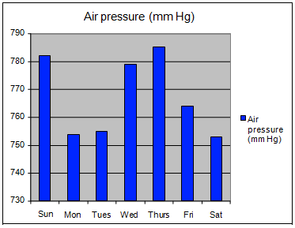

Question 2 Continued: Which of the following tables matches the data above?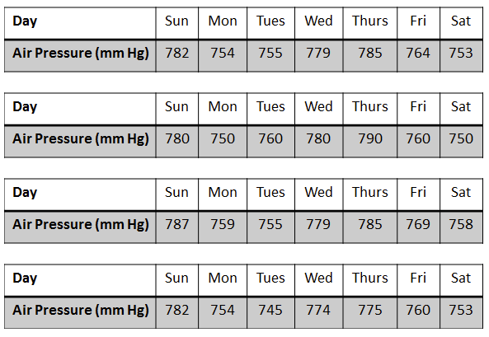
Question 3 .
The United States Department of Agriculture published results on the quantity of organic farmland in the United States. Accompanying their results was the following:
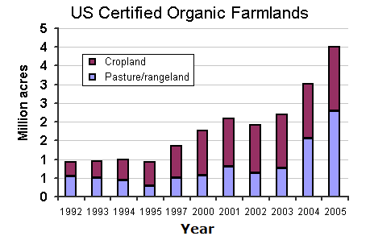
Courtesy of the USDA.
This is an example of how scientists communicate data through _______.
A. data tables
B. conferences
C. conventions
D. graphs

Question 4 .
Which statement below is an inference?
A. The pigeon, with its white and blue feathers, stayed in the courtyard all day.
B. The pigeon was pecking at a disk.
C. The pigeon's pecking was distracted by the sound of a door slamming, so it hesitated while it considered whether to keep pecking or not.
D. The pigeon stopped pecking when the door slammed.
Question 5 .
A patient suffering from a bacterial infection was given antibiotics to take by her doctor. The patient took the antibiotics for 6 days out of a 10 day period. The percentage of bacteria surviving during each day of this period is shown in the table below.
Antibiotic Treatment
Day | Dosage | % of Bacteria Surviving
1 | 300 mg | 85%
2 | 300 mg | 45%
3 | 300 mg | 25%
4 | 300 mg | 5%
5 | 0 mg | 10%
6 | 0 mg | 20%
7 | 0 mg | 45%
8 | 0 mg | 55%
9 | 300 mg | 65%
10 | 300 mg | 70%
Which of the following conclusions is most likely correct?
A. The bacteria developed resistance to the antibiotics.
B. The patient should have not taken the antibiotics again after day 5.
C. The bacteria will be completely killed off if the antibiotics dosage is increased.
D. The patient has become immune to the bacteria by day 10.
Question 6 .
Which of the following is an inference?
A. The little boy ran across the playground.
B. The gorilla was able to jump across the water.
C. Their dog wasn't being playful; therefore, she must be sick.
D. John runs faster than Eric.

Question 7 .
Select the correct graph.
Mikey had two mice that were about the same age and weight. Mikey fed each of the two mice a different feed for a month. He measured how much the mice weighed every two days until the month was over. Mikey's results showed that although both mice gained weight over the month, mouse 2 gained more weight than mouse 1.
Which graph below best shows these results?
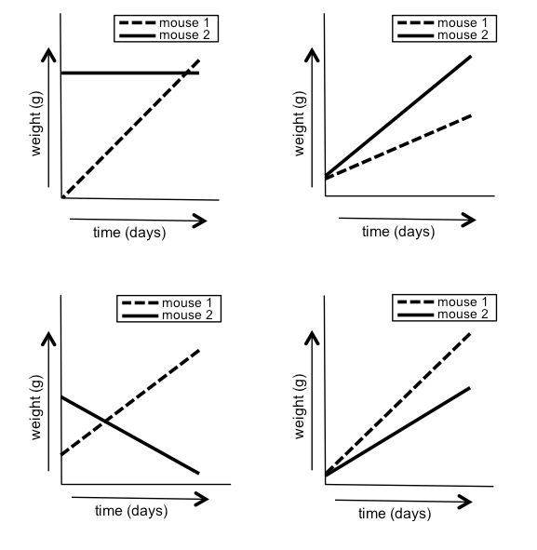

Question 8 .
A scientist collected the following data on algal growth during an experiment:
Algal Growth Rates
Water Temperature (°C) | Time for population to double (hours)
10 | 69
15 | 58
20 | 36
25 | 44
30 | 52
35 | 71
40 | 78
Which of the following conclusions could be drawn from the data?
A. Algae multiply most slowly at 10°C.
B. Algae multiply most slowly at 20°C.
C. Algae multiply most rapidly at 35°C.
D. Algae multiply most rapidly at 20°C.
Question 9 .
The percent composition of a rock sample is as follows:
Silicates | 30%
Iron sulfite | 20%
Copper compounds | 10%
Iron pyrite | 20%
Carbon compounds | 10%
Calcium carbonates | 10%

Total | 100%
Which type of graph would best display these data?
A. pie chart
B. 3-dimensional scatter plot
C. scatter plot
D. line graph
Question 10 .
ABC Gasoline wants to prove that its fuel produces more gas mileage in cars than the leading competitor's fuel. In a test, one gallon of ABC gasoline is put in a car and the car is driven at 50 mph until it runs out of gas. Then, the test is repeated using the competitor's gasoline in the same car on the same road. The results are shown below.
Fuel Type | Gas Mileage | Weather Conditions
ABC | 32 mpg | warm, calm
Competitor | 29 mpg | warm, windy
Question 10 Continued: Which of the following is true?
A. ABC Gasoline can conclude that its fuel produces more gas mileage in cars than its competitor's fuel.
B. No conclusion can be drawn; the differing weather conditions could have influenced the results.
C. No conclusion can be drawn; there are not enough variables in the experiment.
D. ABC Gasoline can conclude that its fuel produces less gas mileage in cars than its competitor's fuel.
Question 11 .
Holly is conducting an experiment in which she changes the voltage across a circuit and records the relative brightness of a light bulb in the circuit. She takes notes in the notebook below.
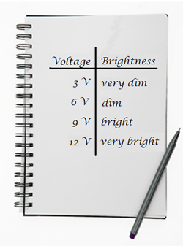
How might these notes be useful?
A. They could help someone interested in conducting the same experiment.
B. They could help her teacher to understand what she did in the experiment.
C. They could help her remember the experiment in the future.
D. all of these

Question 12 .
The pictures below show a field that is being studied over time. In the field, there are rabbits (red circles) and foxes (blue circles). What conclusion can be drawn from these observations?
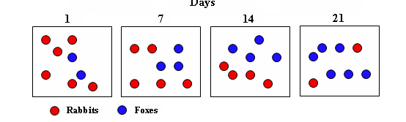
A. The number of foxes remains constant while the number of rabbits decreases.
B. The number of rabbits and foxes remains constant over time.
C. The number of foxes increases while the number of rabbits decreases.
D. The number of foxes decreases as the number of rabbits increases.
Question 13 .
Which of the following is an inference?
A. The man talking to himself in the mall was wearing a black hat and a trench coat.
B. Shoppers in the mall assumed that the man talking loudly to himself was crazy.
C. Shoppers in the mall avoided eye contact with the man that was talking to himself.
D. The man talking to himself in the mall had a cell phone in his right hand.
Question 14 .
A student reads in her science textbook that orange juice is a good source of vitamin C. The student then examines the following nutrition facts label from a bottle of orange juice.
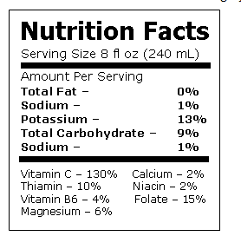
Does the nutrition facts label support the claims made by the science textbook?
A. No, orange juice contains too many carbohydrates to be healthy.
B. Yes, orange juice is a good source of all necessary vitamins.
C. No, orange juice is only a good source of folate.
D. Yes, orange juice contains a large amount of vitamin C.
Question 15 .
Select the correct graph.
During an experiment, Walter measured the increase in a population of mealworms over time. The results of his experiment are shown in the table below.
Day | 0 | 1 | 2 | 3 | 4 | 5
Number of  Mealworms | 2 | 4 | 8 | 16 | 32 | 64
Which graph best represents the data Walter collected?
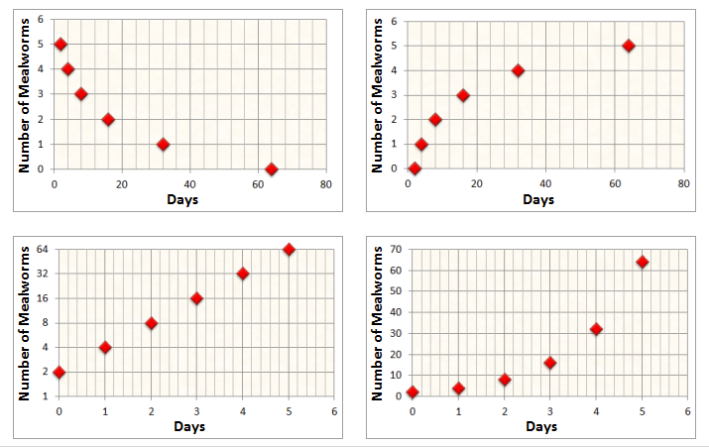
Question 16 .
A scientist is studying which flower color attracts the most bees. To do this, the scientist releases a group of ten honey bees into a chamber with white walls. The chamber contains potted flowers of the following varieties: yellow daffodils, red roses, white daisies, purple asters, and orange lilies.
The results of the experiment is shown in the table below:
Flower | Number of Visits in 30 Minutes
yellow daffodils | 12
red roses | 34
white daisies | 19
purple asters | 28
orange lilies | 30
Question 16 Continued: From the data, the scientist concludes that bees prefer red flowers. Are the scientist's conclusions valid?
A. No, the honey bees showed relatively the same interest in all of the flowers except the daffodils.
B. Yes, the honey bees visited the red roses 34 times during the experiment, which was 4 more times than the next popular flower, the orange lily.
C. Yes, bees are always attracted to the brightest colored flower, which is why there are very few kinds of white flowers.
D. Not necessarily; the honey bees may have been attracted to traits other than flower color.
Question 17 .
Which of the following is an observation?
A. The baby was crying very loudly; therefore, he must have been hungry.
B. John was jumping up and down because he was excited about his new puppy.
C. Stella must have been very upset when she left the room and slammed the door behind her.
D. Jason stared at his computer screen for 2 minutes and then starting typing on the keyboard very rapidly.
Question 18 .
Day # | Volume of Water  Left in Beaker  (mL)
1 | 20
2 | 16
3 | 12
4 | 8
5 | ?
Harry put 20 mL of water in a beaker and wanted to track how the water evaporated each day. What would be the best estimate as to the amount of water left in the beaker at the start of day 5?
A. 8 mL
B. 6 mL
C. 4 mL
D. 5 mL
Question 19 .
A pharmaceutical company states in advertisements that their new ScarX Cream is guaranteed to erase scars in one month.
The company based their claims on a study done by the company's dermatologists.
The study showed that 84 percent of users said the sizes of their scars were reduced after using the product for 50 days. Do the study results support the company's claims?
A. Yes, the results indicated the product is effective against scars.
B. No, no product will ever be able to erase skin scars.
C. Yes, 84 percent of the study's subjects saw positive results.
D. No, the results indicated that the scars were reduced, not erased.
Question 20 .
Animal | Length of Digestive System | Diet Category | Animal Mass
Koala | 305 cm | Herbivore | 10 kg
Dog | 135 cm | Carnivore | 11 kg
Rabbit | 272 cm | Herbivore | 9 kg
Bobcat | 145 cm | Carnivore | 12 kg
Herbivores are animals that eat plants. Carnivores are animals that eat other animals. The table shows data about several carnivores and herbivores. What conclusion can you draw from the data?
A. Carnivores have longer digestive systems than herbivores have.
B. The length of the digestive system is related to the mass of the animal.
C. Herbivores have longer digestive systems than carnivores have.
D. There is no relationship between diet and length of digestive system.
Question 21 .
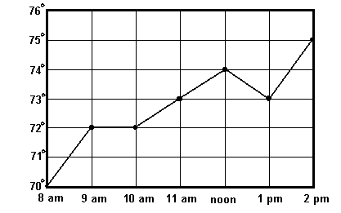
Coach Newman has been keeping a record of the temperature in his classroom in the chart above. What is the difference between the temperature at 8 am and the temperature at 1 pm?
A. 2°
B. 3°
C. 4°
D. 1°
Question 22 .
Which of the following is an observation?
A. The old man was walking with a cane; therefore, he must have an injured leg.
B. The old man looked both ways several times before he stepped off the curb.
C. The old man was walking a dog, so he must be an animal lover.
D. The old man looked both ways several times before he stepped off the curb because he was scared of oncoming traffic.

Question 23 .
Which of the following is an inference?
A. Even though Jennifer didn't say anything, I could tell by her expression that she was having a good time.
B. Everybody at the party wore red hats that had "Happy Birthday!" in green letters.
C. Once Tameka saw her birthday cake, she started to smile.
D. The dog barked for 5 minutes once the candles on the cake were lit.
Question 24 .
Select the correct image.
Mike is conducting an experiment in which he measures the density of several objects and then observes how long it takes each object to sink in a tank of water.
Which table above would be the most useful for Ike to include in his notes?

Question 25 .
Dr. Jalli wonders what antibacterial, or cleaning substance, kills the most bacteria. He designs an experiment to test four antibacterials by putting them onto colonies of bacteria and measuring how much of the bacteria is killed. His results from each of three trials are listed below:
Antibacterial % Bacteria Killed  1 65%  2 23%  3 18%  4 31% | Antibacterial % Bacteria Killed  1 72%  2 17%  3 21%  4 39%
Antibacterial | % Bacteria Killed
1 | 75%
2 | 12%
3 | 18%
4 | 29%

From the information in the tables, which of the following is an appropriate conclusion?
A. Antibacterial 1 was the most effective at killing bacteria.
B. None of the antibacterials killed any bacteria.
C. All of the antibacterials had the same effectiveness at killing the bacteria.
D. Antibacterials 2 and 3 were the most effective at killing the bacteria.
Question 26 .
Susie is conducting an investigation to find out what type of fish are in two ponds near her house. The results are shown in the bar graph below.
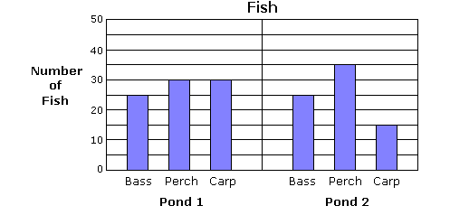

Question 26 Continued.How many more perch are in Pond 2 than Pond 1?

A. 5
B. 8
C. 1
D. 30
Question 27 .
Joseph counted all of the different trees in the woods near his house. He made a graph showing his results.
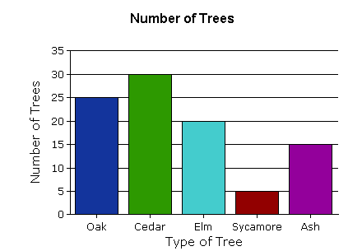
Which of the following conclusions can Joseph draw from his graph?
A. Cedars are the tallest trees in the woods near his house.
B. Maple trees are not able to grow in the woods near his house.
C. There are 95 trees in the woods near his house.
D. There are more elms than oaks in the woods near his house.

Question 28 .
Mr. Swanson's science class used a thermometer to measure the outside temperature each day throughout the school year.
They used their results to make the graph below.
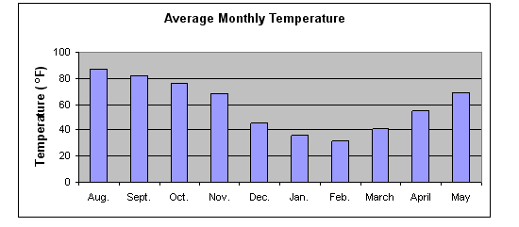
Which month had an average daily temperature of around 82 degrees?
A. August
B. October
C. May
D. September
Question 29 .
Select the correct data table.
In the following experiment, a gas produced by a chemical reaction is being measured as it pushes water out the bottom of a water-filled tube. The tube is graduated in milliliters (ml) on the left. The time in minutes is shown below the tubes. The blue column represents the water, and the white space represents the gas.
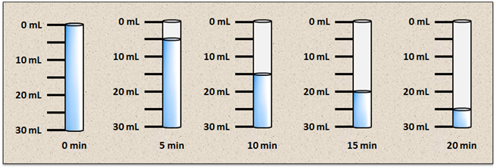

Question 29 Continued: Which table most clearly expresses the data from the experiment so that a conclusion can be drawn about the production of gas with time?
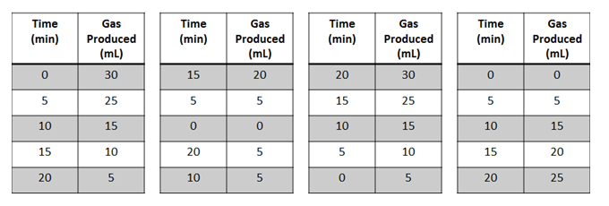
Question 30 .
A scientist is observing a rare monkey in the jungle, and the monkey begins exhibiting an odd behavior. The scientist thinks this behavior may not have been observed in this species before, but he is not certain. The scientist records video of the behavior and takes many detailed notes.
The scientist becomes very excited about his finding and plans to share it with other scientists. The best way for him to communicate and defend his finding would be to
A. immediately write a report claiming a newly discovered behavior, and then check later to see if others have observed it before.
B. confirm that the behavior has not been observed before, and then present his finding in a report.
C. wait until other scientists ask him about his trip to the jungle, and then tell them about his finding.
D. defend his finding as a new discovery, even if another scientist has already published a report about the behavior.

Answers
1. C
2. --
3. D
4. C
5. A
6. C
7. --
8. D
9. A
10. B
11. D
12. C
13. B
14. D
15. --
16. D
17. D
18. C
19. D
20. C
21. B
22. B
23. A
24. --
25. A
26. A
27. C
28. D
29. --
30. B

